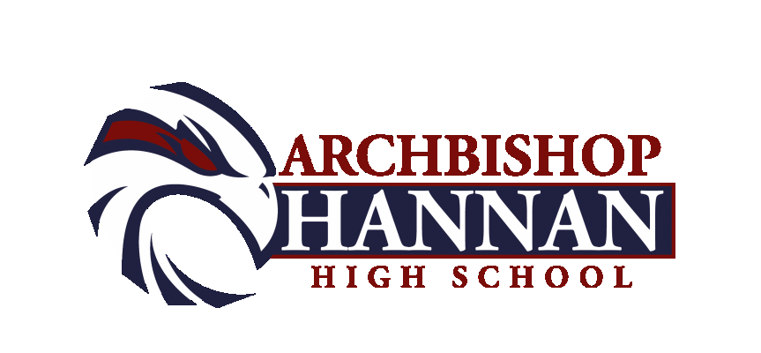

BOYS BASKETBALL ROSTER

0 ETHAN HICKEY 5’7 JUNIOR
1 BEN HUNDLEY 5’11 JUNIOR
2 NORRIS WILLIAMS 6’2 SENIOR
3 JORDAN MARTIN 6’2 JUNIOR
4 BRANTLEY TAYLOR 6’1 SOPHOMORE
10 SHAWN BEATTIE 6’3 SENIOR
11 LONDON NEAL 5’8 SOPHOMORE
12 MASON SCARIANO 5’9 SOPHOMORE
13 KEVIN CARLTON 5’9 SOPHOMORE
15 BRENNAN DORNAN 6’3 SENIOR
21 CANYON CELESTIN 5’11 FRESHMAN
22 ALEX TRONCOSO 5’9 JUNIOR
23 GRANT KEMP 5’9 FRESHMAN
24 JAKE DALMADO 5’8 SOPHOMORE
50 MAJOR GORGONE 5’8 8TH

HAWK PRIDE

Principal: Father Charles Latour

Athletic Director: Joey Hines

Head Coach: Errol Gauff

Assistant Coach: Dale Chimento
Athletic Trainer: Eric Richardson
Student Assistants: Mason Gaiennie, Michael Tucker

BOYS BASKETBALL
J.V. ROSTER

4 BRANTLEY TAYLOR SOPHOMORE
5 MAJOR GORGONE 8TH
11 LONDON NEAL SOPHOMORE
12 MASON SCARIANO SOPHOMORE
13 KEVIN CARLTON SOPHOMORE
20 KAREEM JOHNSON FRESHMAN
21 CANYON CELESTIN FRESHMAN
23 GRANT KEMP FRESHMAN
24 JAKE DALMADO SOPHOMORE
33 LUKE TIMMONS 8TH
35 JAYLEN TAYLOR FRESHMAN

HAWK PRIDE

Principal: Father Charles Latour

Athletic Director: Joey Hines

Head Coach: Errol Gauff

Assistant Coach: Dale Chimento
Athletic Trainer: Eric Richardson

BOYS BASKETBALL ROSTER
FRESHMEN TEAM

5 MAJOR GORGONE 8TH
14 JOSH ALONZO 8TH
21 CANYON CELESTIN 9TH
22 KAREEM JOHNSON 9TH
23 GRANT KEMP 9TH
33 LUKE TIMMONS 8TH
35 JAYLEN TAYLOR 9TH

HAWK PRIDE

Principal: Father Charles Latour

Athletic Director: Joey Hines

Head Coach: Errol Gauff

Assistant Coach: Bart Bonnaffee, Dale Chimento
Athletic Trainer: Eric Richardson

BOYS BASKETBALL ROSTER
8TH GRADE TEAM

5 MAJOR GORGONE 5’8
33 LUKE TIMMONS 5’8
34 HAYDEN MOREL 5’3
42 JOSH ALONZO 6
44 WILLIAM HENRICKLE 5’1
45 TIMOTHY FERR 6’2
50 JACE GUFFEY 5’

HAWK PRIDE

Principal: Father Charles Latour

Athletic Director: Joey Hines

Head Coach: Bart Bonnaffee

Assistant Coach:
Athletic Trainer: Eric Richardson

