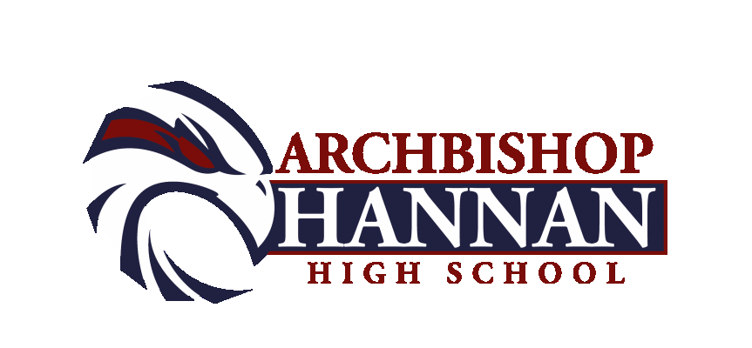

BOYS BASKETBALL VARSITY ROSTER

1 GRANT KEMP 5’10 JUNIOR
2 LONDON NEAL 5’10 SENIOR
3 CANYON CELESTIN 6’ JUNIOR
4 LUKE TIMMONS 5’10 SOPHOMORE
10 KEVIN CARLTON 5’11 SENIOR
11 DREW TIMMONS 6’2 EIGHT
12 MASON SCARIANO 5’9 SENIOR
13
21 RYAN MCDOUGAL 5’6 FRESHMAN
24 KAREEM JOHNSON 5’11 JUNIOR

Head of School: Mr. Chad Barwick

Athletic Director: Mike Perniciaro

Head Coach: Errol Gauff

Assistant Coaches: Dale Chimento and Jon Lanter
Athletic Trainer: Eric Richardson and Abi Feske
Student Assistants:

HAWK PRIDE

BOYS BASKETBALL
J.V. ROSTER

4 LUKE TIMMONS 5’10 SOPHOMORE
5 MICHAEL MAXWELL 5’7 FRESHMAN
11 DREW TIMMONS 6’2 EIGHT
13 ANDERSON SCHOF 5’7 FRESHMAN
15 ETHAN BARRE 5’7 FRESHMAN
20 PRESTON RICHARDSON 5’8 FRESHMAN
21 RYAN MCDOUGAL 5’6 FRESHMAN
23 BILLY RUSH 6’1 FRESHMAN
32 CARTEZ BROWN 5’10 FRESHMAN
33 JORDAN FROEBA 5’6 FRESHMAN

Head of School: Chad Barwick

Athletic Director: Mike Perniciaro

Head Coach: Dale Chimento

Assistant Coach: Jon Lanter
Athletic Trainer: Eric Richardson and Abi Feske

HAWK PRIDE

BOYS BASKETBALL ROSTER
FRESHMEN TEAM

5 MICHAEL MAXWELL 5’7 FRESHMAN
11 DREW TIMMONS 6’2 EIGHT
13 ANDERSON SCHOF 5’7 FRESHMAN
15 ETHAN BARRE 5’7 FRESHMAN
20 PRESTON RICHARDSON 5’8 FRESHMAN
21 RYAN MCDOUGAL 5’6 FRESHMAN
23 BILLY RUSH 6’1 FRESHMAN
32 CARTEZ BROWN 5’10 FRESHMAN
33 JORDAN FROEBA 5’6 FRESHMAN

Head of School: Chad Barwick

Athletic Director: Mike Perniciaro

Head Coach: Jon Lanter

Assistant Coach: Dale Chimento
Athletic Trainer: Eric Richardson and Abi Feske

HAWK PRIDE

BOYS BASKETBALL ROSTER
8TH GRADE TEAM

0 BRENNAN OBEY
11 DREW TIMMONS
14 GRANT SWEENEY
HAYDEN ALONZO
COOPER FLETCHER
22 PATRICK KENNEDY
25 AIDEN ROY
30 SAM LOEB
35 JOHN BORDENAVE
44 ZACH LAURO

Head of School: Chad Barwick

Athletic Director: Mike Perniciaro

Head Coach: Jon Lanter

Assistant Coach:
Athletic Trainer: Eric Richardson and Abi Feske

HAWK PRIDE

