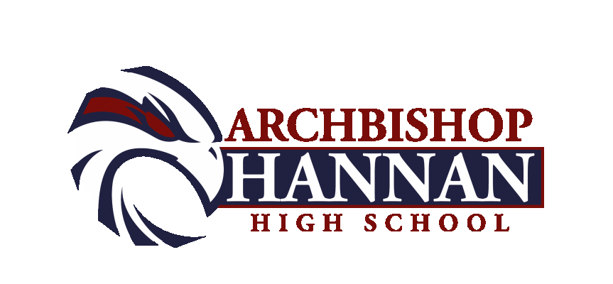2021-2022

Boys Basketball Schedule

Date Opponent Site Time Team(s)
Nov. 10 JAMBOREE Pearl River 5:30 JVB
Nov. 13 JAMBOREE Hannan 11:00am VB
Nov. 17 Helen Cox Hannan 5:30 JVB, VB
Nov. 22-24 Holy Cross Tourney Holy Cross (NO) TBA VB
Nov. 26 East Ascension Mc35 12:00 VB

Dec. 1 East St. John Hannan 5:30 JVB, VB
Dec. 4 Quitman High, Ms. Long Beach High, Ms. 1:00 VB
Dec. 7 Shaw Shaw 5:30 JVB, VB
Dec. 10 Jesuit – Dallas Hannan 7:00 VB
Dec. 16-18 Madison Prep Tourney Madison Prep TBA VB
Dec. 22/23 OPEN
Dec. 28-30 Hannan Hustle Tourney Hannan TBA VB

Jan. 5-8 All State Sugar Bowl Tourney Alario Center (NO) TBA VB
Jan. 11 Loranger Loranger 5:00 JVB,VG, VB
Jan. 14 Bogalusa Bogalusa 5:00 JVB,VG,VB
Jan.18 Albany Hannan 5:00 JVB,VG,VB
Jan. 21 Jewel Sumner Sumner 5:00 JVB,VG,VB
Jan. 25 Salmen Hannan 6:00 JVB, VB
Jan. 28 Loranger Hannan 5:00 JVB,VG,VB
Jan. 29 Walker Walker 3:00 JVB, VB

Feb 1 Bogalusa Hannan 5:00 JVB,VG,VB
Feb. 4 Albany Albany 5:00 JVB,VG,VB
Feb. 5 S. Lab School Lab School (B.R.) 4:00 JVB, VB
Feb. 8 Jewel Sumner Hannan 5:00 JVB,VG,VB
Feb. 11 Helen Cox Helen Cox 5:30 JVB, VB
Feb. 16 Lutcher Lutcher 5:30 JVB, VB
Feb. 18/19 OPEN
Feb. 22 Play offs Begin TBD TBA VB

As of Oct. 16

HAWK PRIDE

Head of School: Chad Barwick Athletic Director: Mike Perniciaro

Head Coach: Errol Gauff Assistant Coach: Dale Chimento

Athletic Trainer: Eric Richardson and Abi Feske

