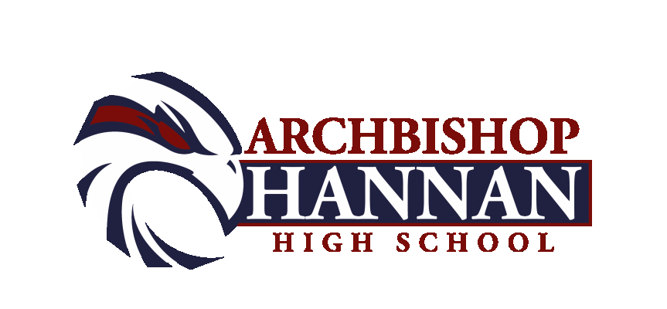2020-2021

Boys Basketball Schedule

Date Opponent Site Time Team(s)
Nov. 11 JAMBOREE Pearl River TBA JVB
Nov. 14 JAMBOREE Hannan VB
Nov. 18 Dunham Hannan 6:00 JVB, VB
Nov. 23-25 Holy Cross Tourney Holy Cross (NO) TBA VB
Nov. 28 Rummel Hannan 3:00 JVB, VB

Dec. 3-5 St. Charles Catholic Tourney SCC TBA VB
Dec. 8 Picayune High Picayune 6:00 JVB, VB
Dec. 10 St. Thomas Aquinas Hannan 5:30 JVB, VB
Dec. 12 East St. John Hannan 3:00 JVB, VB
Dec. 18-19 Holy Savior Menard Tourney HSM (Alexandria) TBA VB
Dec. 22 Mount Hermon Hannan 5:00 JVB,VG,VB
Dec. 28-30 Hannan Hustle Tourney Hannan TBA VG, VB

Jan. 5 Loranger Loranger 5:30 JVB, VB
Jan. 6-9 All State Sugar Bowl Tourney Alario Center (NO) TBA VB
Jan. 12 Bogalusa Bogalusa 5:00 JVB,VG,VB
Jan.15 Albany Albany 5:00 JVB,VG,VB
Jan.19 Jewel Sumner Hannan 5:00 JVB,VG,VB
Jan. 21 Amite Amite 5:30 JVB, VB
Jan. 23 Covington Hannan 4:00 9th,JVB,VB
Jan. 26 Loranger Hannan 5:00 JVB,VG,VB
Jan. 29 Bogalusa Hannan 5:00 JVB,VG,VB

Feb. 2 Albany Hannan 5:00 JVB,VG,VB
Feb. 5 Jewel Sumner Sumner 5:00 JVB,VG,VB
Feb. 9 Riverside Academy Hannan 6:00 JVB, VB
Feb. 11 Terrebonne Terrebonne 5:30 JVB, VB
Feb. 15 Northlake Christian NCS 6:00 JVB, VB
Feb. 19 Warren Easton Hannan 5:30 JVB, VB
Feb. 23 Play offs Begin TBD TBA VB

As of Sept. 29

HAWK PRIDE

Head of School: Chad Barwick Athletic Director: Mike Perniciaro

Head Coach: Errol Gauff Assistant Coach: Dale Chimento

Athletic Trainer: Eric Richardson and Abi Feske Jon Lanter

Hustle Commits:
Grace King Fountainbleau St. Helena Bro. Martin
Mandeville Northlake Christian Northshore Hannan

2020-21

8TH & 9TH GRADE Boys Basketball Schedule

Date Opponent Site Time Team(s)

Nov. 3 Trafton Academy Trafton 8th
Nov. 13-14 Jr. High Jamb STA TBD 8th
Nov. 21 Lakeshore Tourney Lakeshore 9th

Dec. 1 Rummel Rummel 6:00 8th & 9th
Dec. 2 Trafton Academy Hannan 8th
Dec. 12 Jesuit Hannan 10:00am 8th & 9th
East St. John Hannan 9th
Dec. 17-19 Trafton Christmas Tourney Trafton TBA 8th
Dec. 21 St. Michael’s St. Michael (B.R.) 6:00 9th
Dec. 22 Rummel Hannan 10:00am 8th & 9th
Dec. 28 Hannan Hustle Tourney Hannan 9th

Jan. 6 St. Charles Catholic Hannan 6:00 8th & 9th
Jan. 18 St. Michael’s Hannan 6:00 9th

Feb. 1 Parkview Baptist PBS 6:00 9th & JV
Feb. 3 St. Charles Catholic SCC 6:15 8th & 9th
Feb. 6 Jesuit Jesuit 10:00am 8th & 9th

As of Oct. 9.

HAWK PRIDE

Head of School: Chad Barwick

Athletic Director: Mike Perniciaro

Head Coach: Jon Lanter

Athletic Trainer: Eric Richardson and Abi Feske

