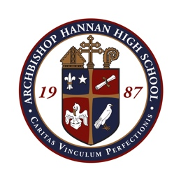

Date | Opponent | Location | Time
Nov. 11 | Mandeville (Scrimmage) | Coquille | 6 p.m.
Nov. 14 | Fontaineblue (Scrimmage) | Coquille | 6 p.m.
Nov. 18 | New Iberia | New Iberia Senior High School | 4 p.m. (Check out 12 p.m.)
Nov. 20 | Archbishop Rummel | Coquille/Hannan | 5 p.m.
Nov. 22 | Northshore High | Northshore High School | 5:30 p.m. (Check out 2:45 p.m.)
Nov. 25 | OPEN | TBD | TBD
Dec. 6-7 | Lion Cup | Lamar Dixon Expo Center | All Day
Dec. 9 | St. Thomas Aquinas | Hannan | 5:30 p.m.
Dec. 11 | Pope John Paul II | Hannan | 7 p.m.
Dec. 12 | Christ Episcopal | Away | 6 p.m.
Dec. 20 | Parkview Baptist | Away | 6 p.m.
Dec. 27-28 | Hannan Christmas Showcase | Hammond | TBD
Jan. 6 | Pearl River | Hannan | 7 p.m.
Jan. 8 | University Lab | Away | 7 p.m.
Jan. 10 | New Orleans Military and Maritime Academy | Away | TBD
Jan. 13 | OPEN | TBD | TBD
Jan. 17 | Kenner Discovery | Away | TBD
Jan. 20 | Vandebilt Catholic | Away | 5:30 p.m. (Check out 2:30 p.m.)
Jan. 24 | International High School of New Orleans | Home | 7 p.m.
Jan. 25 | Ben Franklin | Home | 1 p.m.
Jan. 27 | Lakeshore | Away | 7 p.m.
Jan. 29 | OPEN | TBD | TBD
Feb. 1 | Holy Cross | Home | 7 p.m.

